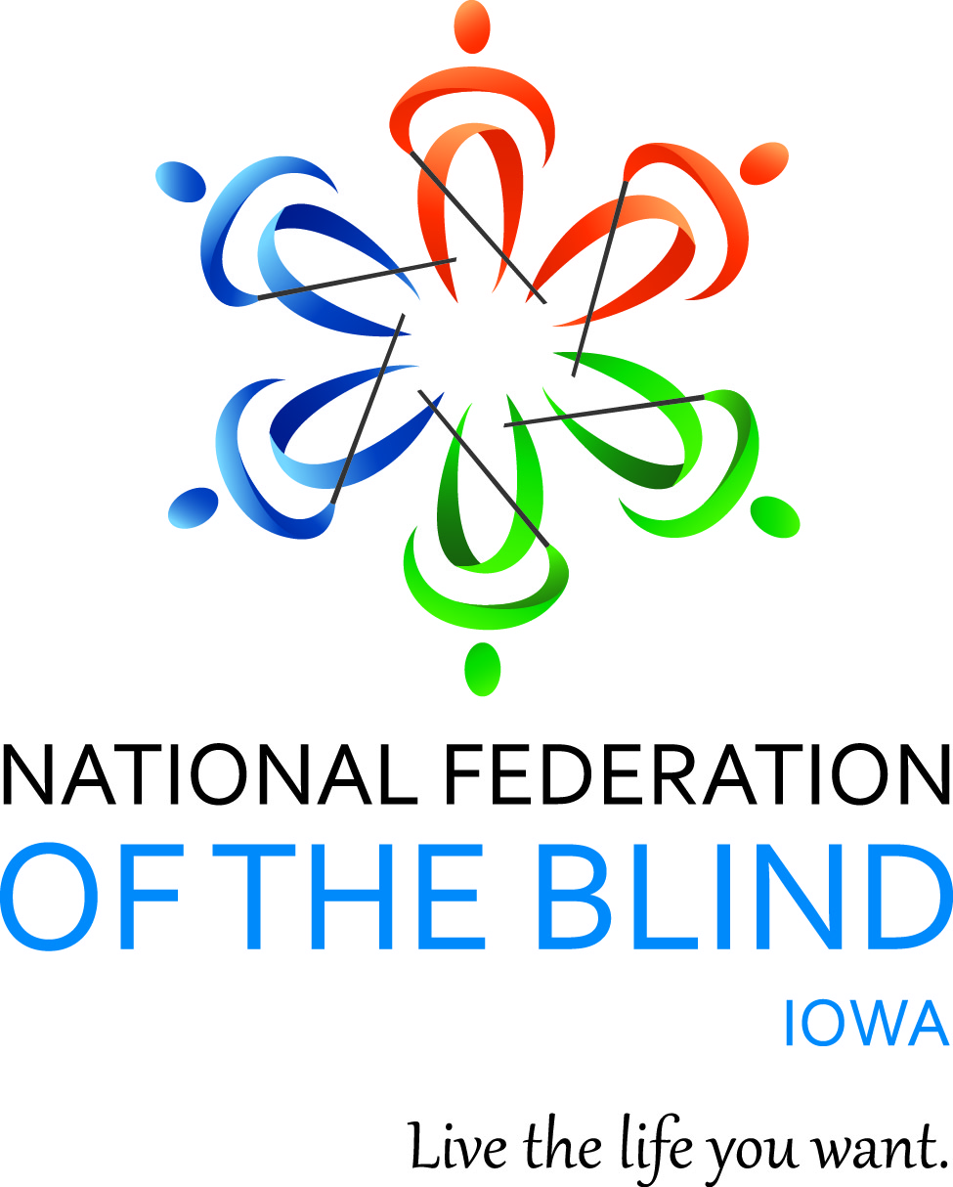

NATIONAL FEDERATION OF THE BLIND OF IOWA
98th Annual STATE CONVENTION
New Beginnings:
More in 2024
October 18–October 20, 2024

Holiday Inn and Suites Des Moines Northwest
4800 Merle Hay Road
Urbandale, IA 50322

Scott Van Gorp, President
E-Mail: svangorp@nfbi.org
Cell: (515)720-5282
Website: www.nfbi.org

If you have questions or need assistance during the convention, contact Convention Coordinator Cindy Ray, (Cell: 515-208-2351)

The members of the planning committee welcome you to the 2023 National Federation of the Blind of Iowa state convention!

Scott Van Gorp, President, NFBI
Cindy Ray, Convention Coordinator, First Vice-President; NFBI
Becky Young, Door Prize Coordinator and President, Des Moines Chapter; NFBI
Helen Mejia, Registration Chair and Vice-President, Des Moines Chapter, NFBI
Bob Ray, Legislative Chair, NFBI
Enrique Mejia, NFBI board member, Des Moines Chapter, NFBI
Committee Chairs
Bob Ray, Nominating
Cindy Ray, Resolutions
Karen Clayton, Audit
Mary McGee, Fund raising
Terri Wilcox and Cindy Ray, Outreach

2023-2024 OFFICERS AND BOARD ,
Scott Van Gorp, President, Des Moines, svangorp@nfbi.org
Cindy Ray, First Vice-President, Urbandale, cray@nfbi.org
Vacant, Second Vice President
Terri Wilcox, Secretary, Urbandale, trising1943@gmail.com
David Hammel, Treasurer, Urbandale, dhammelia@aol.com
Becky Young, Board Member, Urbandale, byoung@nfbi.org
Enrique Mejia, Board Member, Des Moines, emejia@nfbi.org
Tom Venesky, Board Member, Sioux City, tomvenesky2@gmail.com
Richard Webb, Board Member, Burlington, NF5B@mediacombb.net

Use the hashtag: #NFBIA2024
Like us on Facebook: National Federation of the Blind of Iowa
Follow us on X (Formerly Twitter): @NFB_Iowa
Sign up for the Tall-Corn mailing list to get our latest information

AGENDA

Friday, October 18, 2024
8:00 A.M.–9:00 A.M. In-person registration and online registration packet pickup - prefunction foyer outside of Salons B and C
9:00 A.M.–9:00 P.M. Exhibits – Prefunction Foyer between Salons B and C
9:00 A.M.-12:00 P.M. Seniors Group Seminar –See separate agenda for this event Bob Ray, NFBI Seniors Group coordinator, Des Moines Chapter, NFBI - Bennigan's Meeting Room
12:30 P.M. - 1:30 P.M. In-person registration and online registration packet pickup - prefunction foyer outside of Salons B and C

Friday General Session – Salon C
1:30 P.m. Call to Order: Scott Van Gorp, President, National Federation of the Blind of Iowa
1:35 P.m. Opening Ceremonies
Invocation: Cindy Ray, First Vice-President, NFBI
Pledge of Allegiance
National Federation of the Blind Pledge
Welcome (TBD)
1:45 P.M. Convention Arrangements: Cindy Ray, Convention Coordinator and First Vice-President, NFBI
1:50 P.M. A partnership benefitting the blind of Iowa from a grant that supports multiple disability groups - Helen Mejia, Vice-President, Des Moines chapter, NFBI and member, legislative committee, NFBI
Brooke Lovelace, Director, Iowa Developmental Disabilities (DD) council and White Cane Sponsor of this convention
Bob Ray, Legislative Chair and member, Des Moines chapter, NFBI
2:20 P.M. Continuing partnership on voting an other disability rights issues, an update from Disability Rights Iowa (DRI) – Representatives of DRI
2:40 P.M. Panel discussion on accessible voting in Iowa. We’ll hear about efforts to bring accessible voting to Iowa and brainstorm ideas on how we as an affiliate can influence policy makers to make accessible absentee voting a reality! – Moderated by Bob Ray, Des Moines Chapter, NFBI
Panelists:
Josh Nelson, Iowa Secretary of State’s Office,
Mark Riccobono, National Representative and President, National Federation of the Blind
Representatives from Democracy Live
3:30 PM. Updates from our legislative committee and a report from those helping NFBI push for accessible prescription labels – Bob Ray, chair of the NFBI legislative committee
Helen Mejia, Vice-President Des Moines chapter, NFBI and legislative committee member
Sharla Glass – Envision America, Bronze sponsor at this convention
4:00 P.M. Latest updates from the movement – Mark Riccobono, National Representative and President, National Federation of the Blind
4:30 P.M. Adjourn
4:30-5:00 p.m. Resolutions Committee Meeting Cindy Ray, Chair
Open to all. Hear the resolutions before they come to the convention floor for a vote. – Salon C
5:00 P.M.- 6:15 P.M. In-person registration and online registration packet pickup - prefunction foyer outside of Salons B and C
5:00-6:45 P.M. Welcome reception and meal
Mix and mingle with old and new friends and enjoy delicious food as we celebrate being together over the last year. – Salon C
7:00-11:00 P.M. Hospitality – Convention planning committee
Join us for a great time for networking and to mix and Mingle in person. You never know what could happen! There might even be games and trivia involved – Salon C
Refreshments will be available.

Saturday, October 19, 2024
7:00 A.M-5:00 P.M. Exhibits – Prefunction Foyer between Salons B and C
7:00-8:00 A.M. President’s plated breakfast – Salon C
7:30-9:00 A.M. Final Registration/packet pickup – Prefunction foyer outside Salons B and C
8:00-8:45 A.M. Affiliate Board Meeting – Salon C
Scott Van Gorp, President, NFBI

Saturday GENERAL SESSION – Salon C
9:00 A.M. Call to Order and invocation
9:05 A.M. Presidential Report – Scott Van Gorp, President, NFBI
9:30 A.M. Updates on non-24 Sleep Wake Disorder and other items of interest From one of our silver convention sponsors
– Jennifer Lyman, RN, nurse educator, Vanda Pharmaceuticals
10:00 a.m. Report from the Iowa Department for the Blind – Sarah Willeford, Director, Iowa Library for the Blind and Print Disabled and interim Director, Iowa Department for the Blind
10:30 A.M. Assistive technology for the blind – Two companies whose mission is to empower and enrich the lives of the blind in work, in leisure, in life – Earl Harrison Selvas BLV, silver convention sponsor
Joel Zimba, Humanware, bronze convention sponsor
11:00 A.M. Cultivating leaders in the movement, experiences from the first year of the Kenneth Jernigan Leadership in Service Program – Becky Young, President, Des Moines chapter and board member, NFBI
11:15 A.M. Advocacy in Action, a first-hand account of activities at the Rideshare Rally held in San Francisco, California – Helen Mejia, Vice-President, Des Moines chapter, NFBI
11:30 A.M. Report on the recently completed Braille camp held in Des Moines, Iowa as part of the 2024 NFB BELL program – Becky Young, President, Des Moines chapter, NFBI and NFBI BELL coordinator
Chelsea Van Gorp President At Large chapter, NFBI and NFBI BELL co-coordinator
Helen Mejia, Vice-President, Des Moines chapter and NFBI BELL lead teacher
11:45 A.M. A scholarship winner’s “Thank you” – remarks from our most recent NFB national scholarship winner – Enrique Mejia, Des Moines chapter and affiliate board member, NFBI
12:00 p.m. Adjourn
12:15-1:45 P.M. Lunch – Come and enjoy food and fellowship with the Federation Family and share stories from the past and dreams for the future. We are also pleased to welcome this year’s luncheon keynote speaker, Shawn Mayo, Des Moines chapter – NFBI. – Salon C
Saturday Breakout Sessions
2:00-3:15 P.M. Annual meeting of the At Large Chapter, National Federation of the Blind of Iowa – Chelsea Van Gorp, President – Salon C
History of the National Federation of the Blind of Iowa – Bob Ray, Des Moines Chapter, NFBI – Bennigan’s Meeting Room
Parents of Blind Children – Enrique Mejia, Des Moines chapter and affiliate board member, NFBI– Salon D
3:30-4:45 P.M. Fund Raising Strategy Session – Mary McGee, NFBI fund raising chair, Des Moines chapter, NFBI – Salon C
Blind Parents discussion – Helen Mejia, Vice-President, Des Moines chapter, NFBI– Salon D
History of the National Federation of the Blind of Iowa – Bob Ray, Des Moines Chapter, NFBI – Bennigan’s Meeting Room
6:00-6:45 P.M. Meet and Greet –Salon C
Refreshments available.
7:00 p.m. Annual Banquet – Salon C
Master of Ceremonies: Cindy Ray – First Vice-President, NFBI
Invocation: Cindy Ray, First Vice-President, NFBI
Banquet Address: Mark Riccobono, – National Representative and President, National Federation of the Blind
PAC Plan: Mark Riccobono, – National Representative and Elizabeth Rouse, Pac Chair for Iowa, Old Capitol Chapter, NFBI
Money for the Movement – Bring your unwanted items to auction off for a good cause! Proceeds go to support the work of the National Federation of the Blind of Iowa – Mark Riccobono , National Representative and tonight’s auctioneer. We will except cash, checks and Square transactions as forms of payment!
Final remarks and adjournment – Scott Van Gorp, President, National Federation of the Blind of Iowa

Following Banquet:
Convention Planning Committee host hospitality
After the banquet it’s another evening for networking and to mix and mingle! Anything can happen, so come join us! – Salon C
Refreshments available

Sunday, October 20, 2024
Business Session – Salon C
9:00 A.M. Call to Order
9:05 A.M. Remembering the ones we’ve lost over this last year – Cindy Ray, First Vice-President, NFBI
9:10 A.M. Business Meeting
2023 Meeting Minutes –Terri Wilcox, Secretary, NFBI
Treasurer’s Report – David Hammel, Treasurer, NFBI
Audit Committee Report – Karen Clayton, Audit Committee Chair and Secretary, Siouxland chapter, NFBI
Resolutions Committee Report –Cindy Ray, Resolutions Committee Chair and First Vice President, NFBI
10:00 A.M. Report from the Friends of the Library
10:10 A.M. Chapter, Division, and Committee Reports
NFB Newsline Report – Chelsea Van Gorp, NFB Newsline Coordinator for Iowa and President, At Large Chapter, NFBI
10:30 A.m. Elections – Bob Ray, Nominating Committee Chair, Des Moines chapter, NFBI
Election of 5 officers and 2 board members for two-year terms. Election of Delegate and Alternate delegate to the 2025 National Convention in New Orleans, Louisiana
Old Business
New Business
11:30 A.m. Final Remarks –Mark Riccobono, National Representative, and Scott Van Gorp, President, National Federation of the Blind of Iowa
12:00 Noon Adjourn

Convention Notes:
Please take the time to visit our sponsors and exhibitors and thank them for supporting the work of the National Federation of the Blind of Iowa. Thank you to the following sponsors and exhibitors for being a part of our 98th convention!
Silver Sponsors:
Selvas BLV
Vanda Pharmaceuticals
Bronze Sponsors
Democracy Live
HumanWare
Envision America
White Cane Sponsors
Iowa Developmental Disabilities (DD) council
Nanopac

Exhibitors:
Disability Rights Iowa (DRI)
Old Capitol Chapter, NFBI

For those who need it, there is a dog relief area at the hotel. As you exit the west entrance, turn north and go about 50 paces until you are along the fence. Bags and a waste receptacle are available.

There will be door prizes drawn throughout general sessions, the banquet, and the business meeting. Please bring your door prizes to convention if they haven’t been sent ahead of time. We will have a baked goods auction interspersed throughout sessions as well. Also, please don’t forget to buy popcorn and support the affiliate at the same time!

Dream Makers Circle

You can help build a future of opportunity for the blind by becoming a member of our Dream Makers Circle (DMC). It is easier than you think. You can visit your bank and convert an account to a P.O.D. (payable on death) bank account, which is payable after your passing to the National Federation of the Blind or one of our affiliates. Your legacy gift to the National Federation of the Blind or the National Federation of the Blind of {insert state} can be made in the form of a will or living trust, an income generating gift, or by naming us as the beneficiary of a retirement plan, IRA, pension, or a life insurance policy. You can designate a specific amount, a percentage, or list the NFB as one of several beneficiaries. For additional information, please contact Patti Chang at 410-659-9314, extension 2422 or at pchang@nfb.org.

Vehicle Donations
The National Federation of the Blind uses car donations to improve the education of blind children, distribute free white canes, help veterans, and so much more. We have partnered with Vehicles for Charity to process donated vehicles. Please call toll-free 855-659-9314, and a representative can make arrangements, or you can donate online by visiting https://nfb.org/vehicledonations.

Preauthorized Contributions
Can you help the National Federation of the Blind on a regular basis? Please consider joining our preauthorized contribution (PAC) plan. Starting at $5 monthly, you can help us turn dreams into reality and raise expectations. Call 877-632-2722, visit: https://nfb.org/pac to fill out the online form, or email pac@nfb.org for additional information.

MISSION OF THE NATIONAL FEDERATION OF THE BLIND OF IOWA

The National Federation of the Blind of Iowa knows that blindness is not the characteristic that defines you or your future. Every day we raise the expectations of blind people, because low expectations create obstacles between blind people and our dreams. You can live the life you want; blindness is not what holds you back.

THE NATIONAL FEDERATION OF THE BLIND PLEDGE

I pledge to participate actively in the efforts of The National Federation of the Blind to achieve equality, opportunity, and security for the blind; to support the policies and programs of the federation; and to abide by its constitution.

